David Ziegelbauer

User Guide

TicketPro

Table of Contents

Getting Started 2

Managing Tickets 5

Creating a Ticket 5

Updating a Ticket 7

Deleting a Ticket 8

Using the Ticket Search 8

Reports 9

Managing Your Account 10

# Getting Started

Because of the sensitive nature of the data stored in the application, you will have no access to functionality without logging in. Upon opening the application for the first time, you will be greeted with the login screen as depicted below.

Figure 1: The login screen

If you have an account, you will be able to enter your email address and password to log into the application. If you do not have credentials you will have to use the register link at the bottom or in the navigation menu on the left side. Either link will take you to the registration page.

Figure 2: The registration page

On the registration page, complete all the fields then submit your registration request. Once your request is approved you will be prompted to confirm your account.

Figure 3: Account confirmation prompt

Once you’ve confirmed your account, you’ll be ready to log in.

Figure 4: Successful registration

After navigating back to the login screen, enter your credentials to lo g in to the application.

Figure 5: Login screen filled out

This will take you to the home screen. You will be presented with a report on the number of tickets in the open, assigned, or deferred status which might need action. You will also be presented with a new navigation menu with more options. We’ll cover these new options in the following sections.

Figure 6: The home screen

# Managing Tickets

As the name suggests, the bulk of the actions available in TicketPro revolve around managing tickets. Tickets can be created, modified, assigned to a status and/or technician, as well as deleted. In the next section we’ll create our first ticket.

## Creating a Ticket

Begin by selecting the “Manage Tickets” option from the navigation menu. This will bring you to the ticket management console.

Figure 7: Ticket management console

This screen lists all tickets currently in the system sorted by recency. Selecting “Create Ticket” in the upper right corner will bring you to the ticket creation screen.

Figure 8: Ticket creation screen

Creating a ticket is as simple as filling out the five fields on the form and clicking “Create”. All five fields are mandatory, although the ticket can be left in an open and unassigned state if the technician who will work the ticket has not yet been decided. You may also discard your new ticket without saving it by clicking the “Back” button or navigating away using the menu. After creation of a new ticket, you will receive confirmation and the form will be reset.

Figure 9: Successful ticket creation

## Updating a Ticket

To update a ticket, locate it through either the ticket management page or the ticket search page (either option will work) and select the “Update” button next to it. This will bring you to the ticket update page.

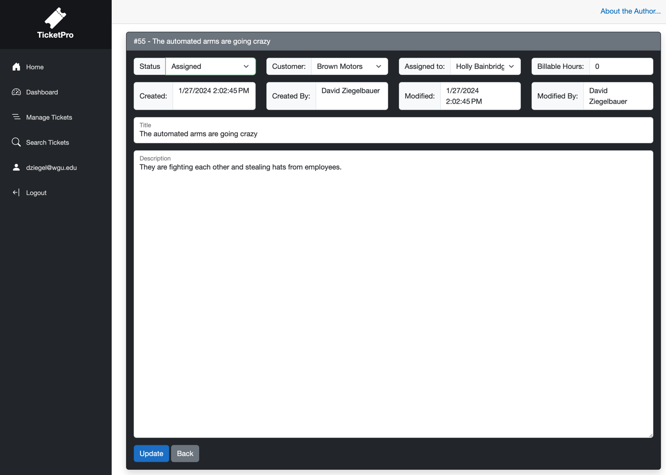

Figure 10: Ticket update page

From this page, you can review the details of the ticket and make any required changes such as updating what work has been accomplished or logging billable hours. The ticket can also be re-assigned from this page. Much like the creation page, once you’ve completed your changes you can save them by clicking “Update” or discard them by clicking “Back” or otherwise navigating away.

## Deleting a Ticket

Deleting a ticket can be accomplished from either the ticket management page or the ticket search page. Clicking the “Delete” button next to a ticket will prompt you for confirmation of the action.

Figure 11: Deletion prompt

Clicking “OK” will delete the chosen ticket.

## Using the Ticket Search

The ticket search page can be accessed by selecting “Search Tickets” from the navigation menu. This will open the ticket search page and present you with search options.

Figure 12: Ticket search page

You many select any combination of filters to search by and the system will return a list of all matching tickets. The “created after” and “created before” fields use an implied time of 00:01. This will cause the “created after” field to be inclusive and the “created after” field to be exclusive. The search text looks for the provided string of characters in the ticket title and the ticket body. Any occurrence will cause the ticket to be returned.

# Reports

Reporting functionality is accessible through the “Dashboard” option in the navigation menu. On this screen you’ll find six different reports reflecting the performance data of employees and the business presented in an easily consumable visual format.

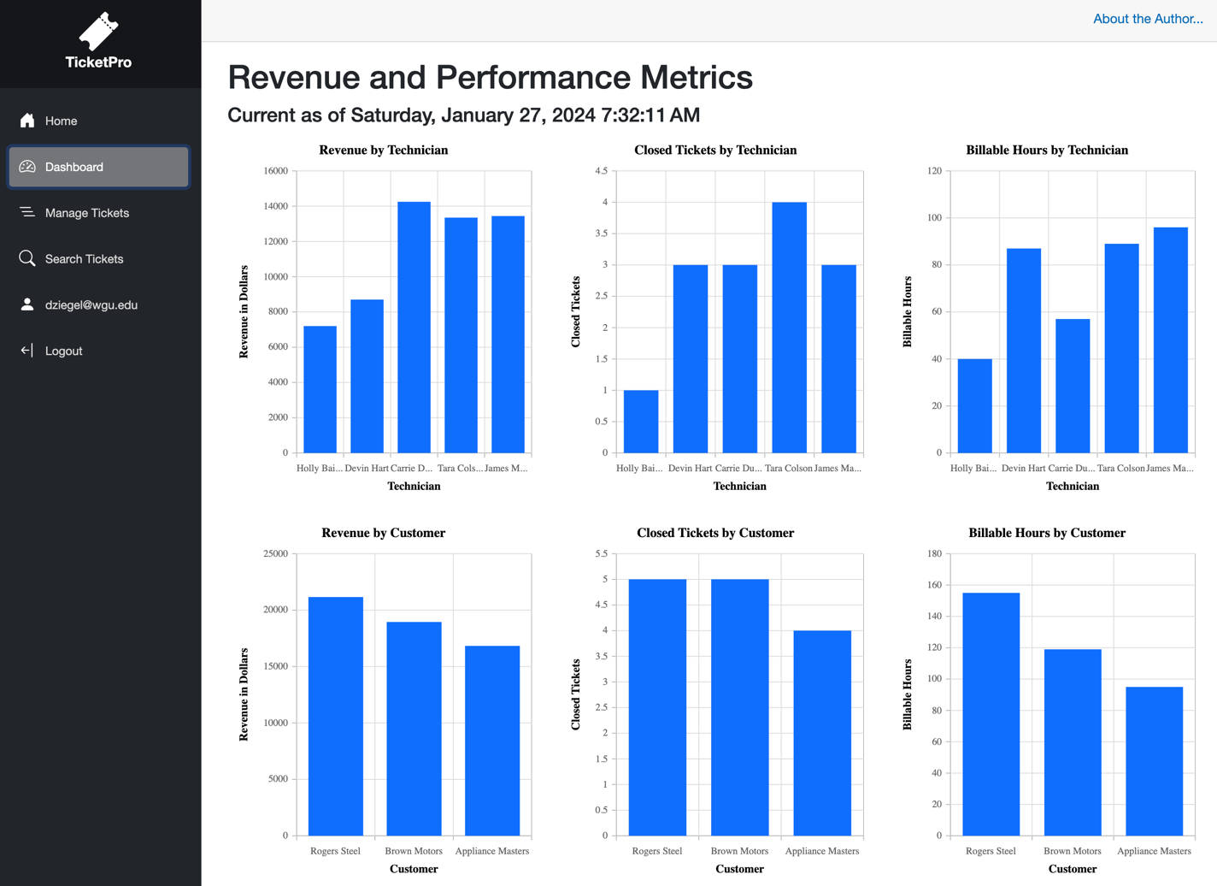

Figure 13: Dashboard page

# Managing Your Account

By selecting your email address on the navigation menu, you will navigate to the account management page.

Figure 14: Account management page

The account management page has the following features:

* From the “Profile” tab you can update the Phone number associated with your account.
* From the “Email” tab you can change the email address associated with your account.
* From the “Password” tab you can change your password.
* The “Two-factor authentication” feature is not implemented in the MVP
* From the “Personal data” tab you can delete your account and personal data from the application.